Email Listeners Day1:

In Email Listeners when ever emails comes to INBOX(Not exactly the inbox it is specified folder in Email Inbox/Pradeep) Basically in Email listener we are going to mention the folder path. And it is going to read the email and handed it over to service Email.

Whenever email listener is handed it over to service email service email is going to execute an activity (i.e pyCreateAndManageWorkEmail)

Service email is going to read all parameters (i.e To , CC, ……….etc) & Body of the email as well (i.e. ., Message data) all this content is available on the clipboard(i.e pyinbound.pyTo , pyinbound.pyTocc)

Problem Statement: when we receive an Email ,Email Should be processed and create work object?

In order create Email Listerns (Inbound Email)

To work with inbound email integrations we need to create below rules:

1. Email account

2. Service Package

3. Service Email

4. Email listeners

5. Activity

6. Flow

Step1: Email account

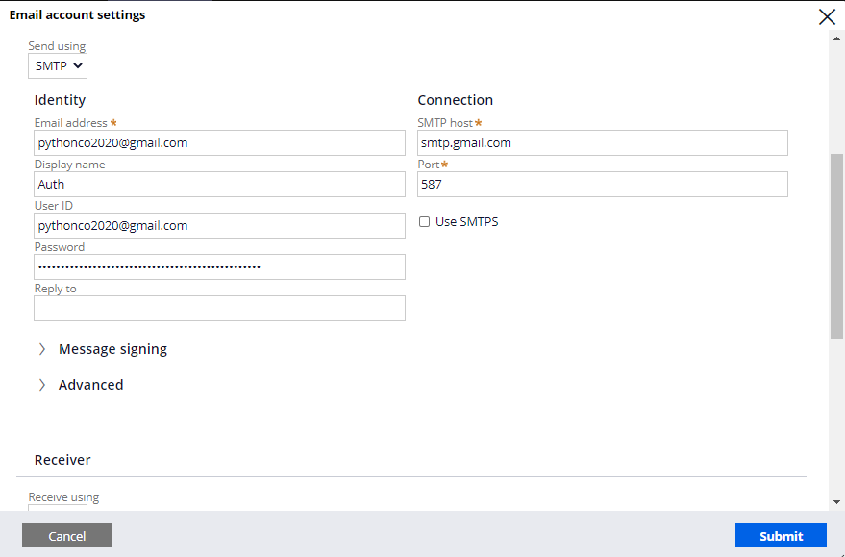

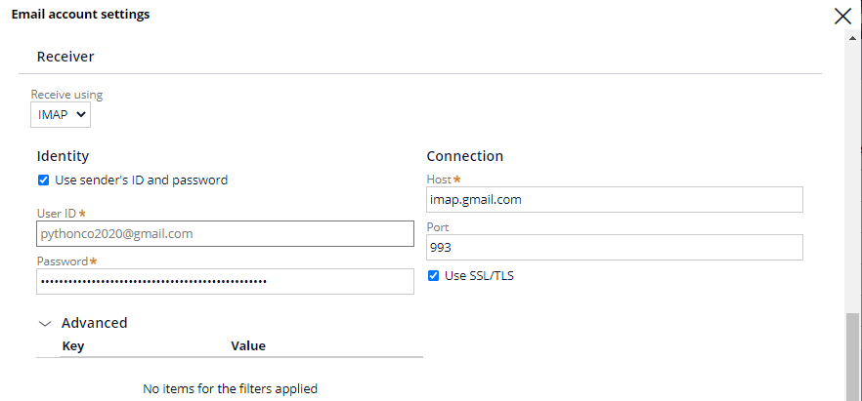



Step2: Service Package

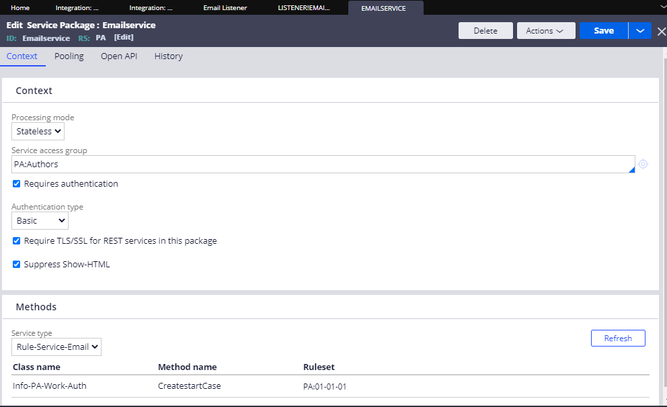

Step 3: Service Email

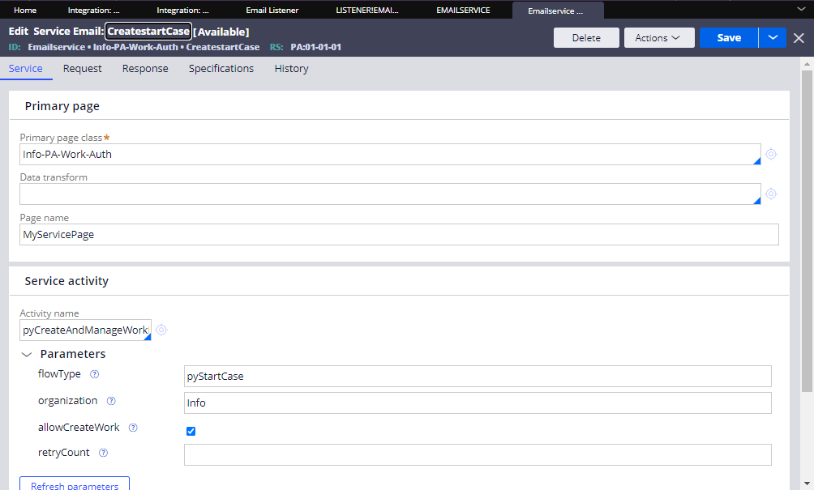

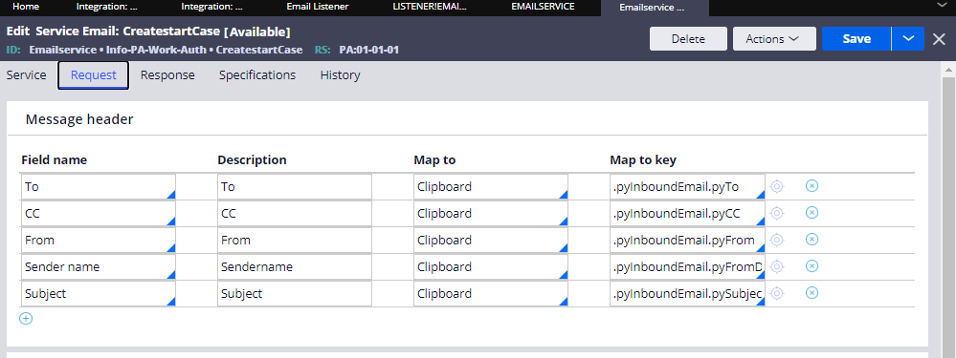

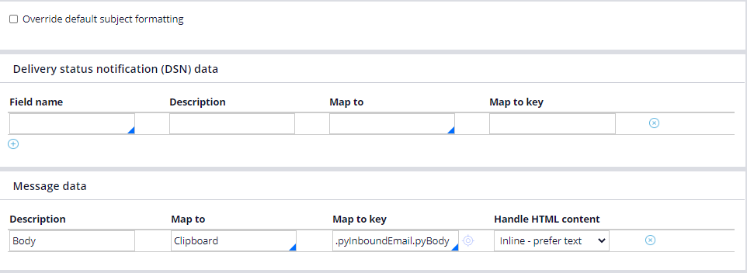

Step3:Email Listener

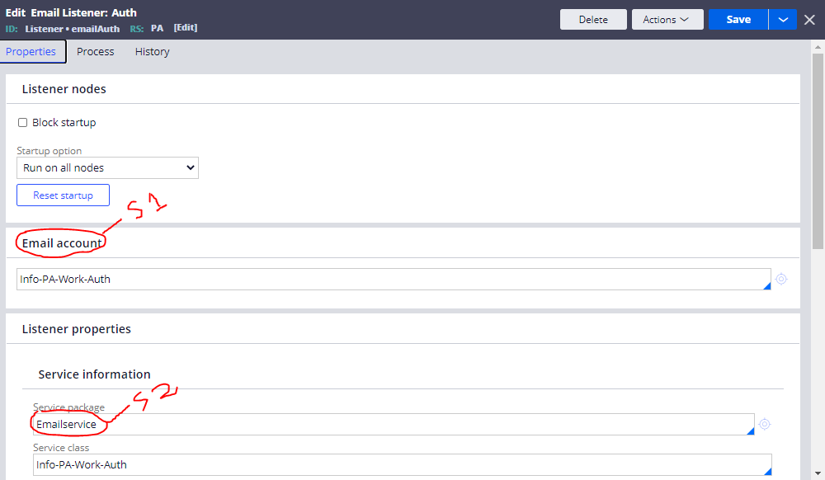

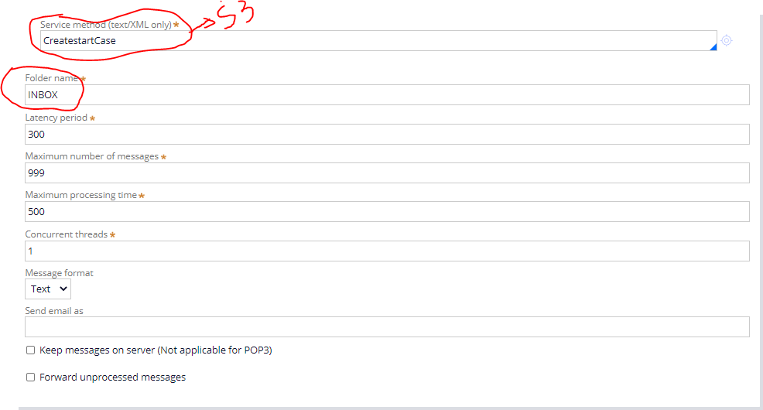

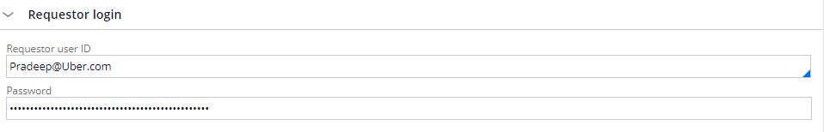

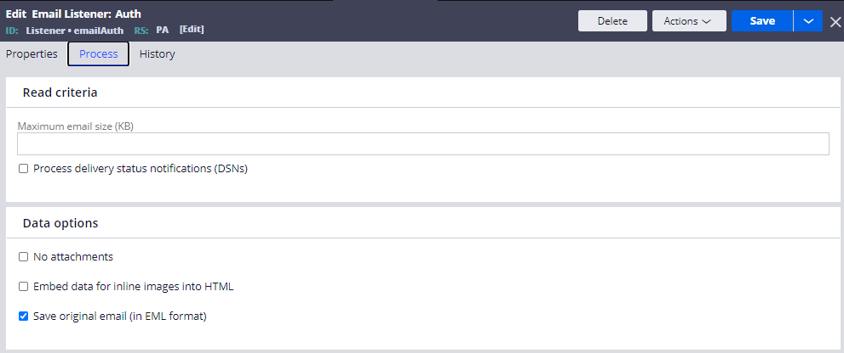

Lets Test in Admin Studio :

